Consider a unity feedback control system with Gc(s)=K and R(s)=0 for inverted pendulum (example 3.3) in textbook.

Analyze C1 = [0,0,1,0], C2 = [0,0,1,1], and C3 = [0,1,1,1] and different K.

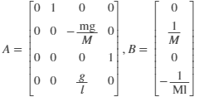



1) use Simulink to simulate the output response for different K in s-domain.

* For K = -36,
  + C = C1 = [0,0,1,0]

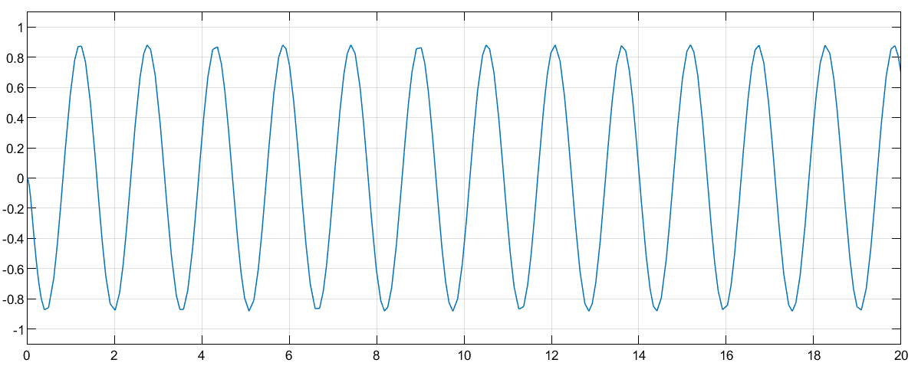

* + C = C2 = [0,0,1,1]

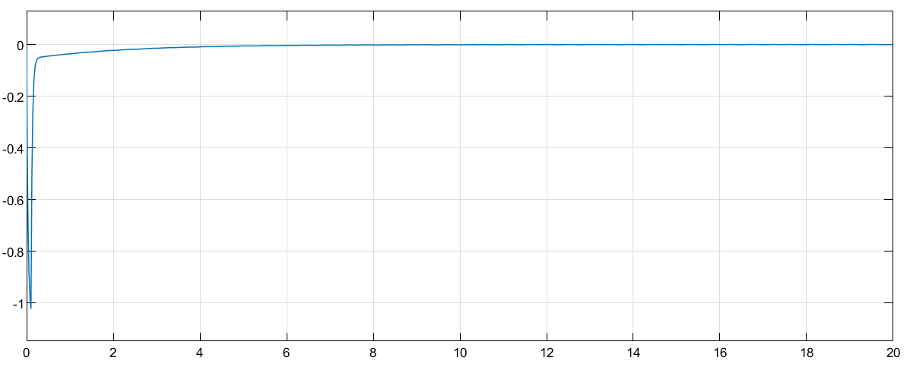

* + C = C3 = [0,1,1,1]

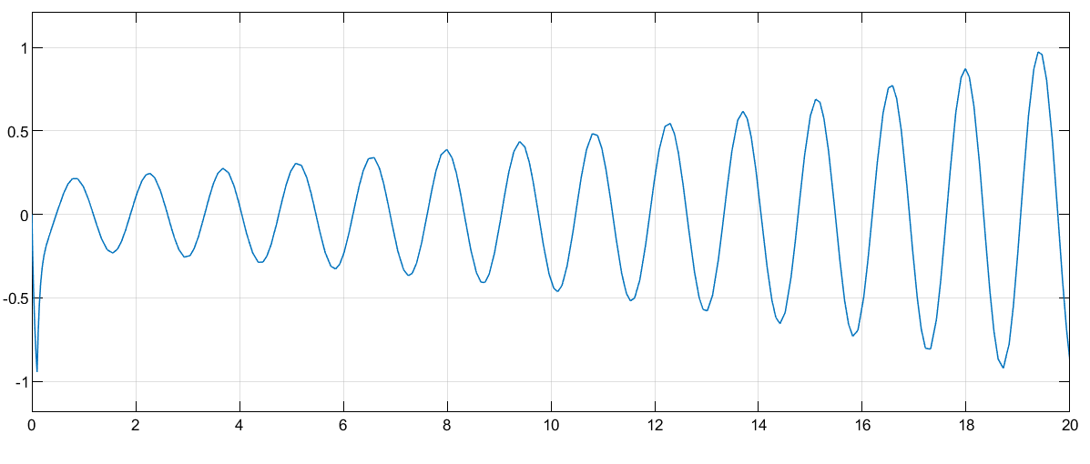

* For K = -18,
  + C = C1 = [0,0,1,0]

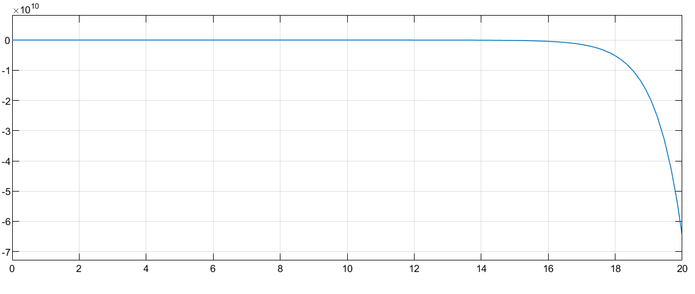

* + C = C2 = [0,0,1,1]

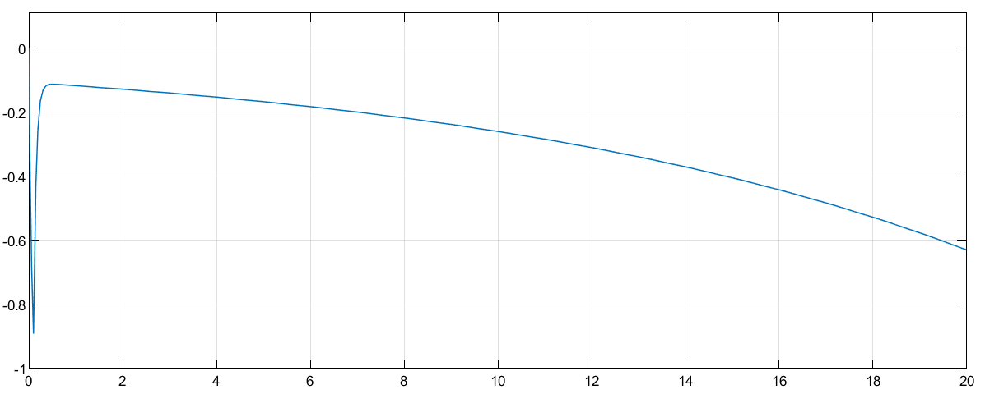

* + C = C3 = [0,1,1,1]

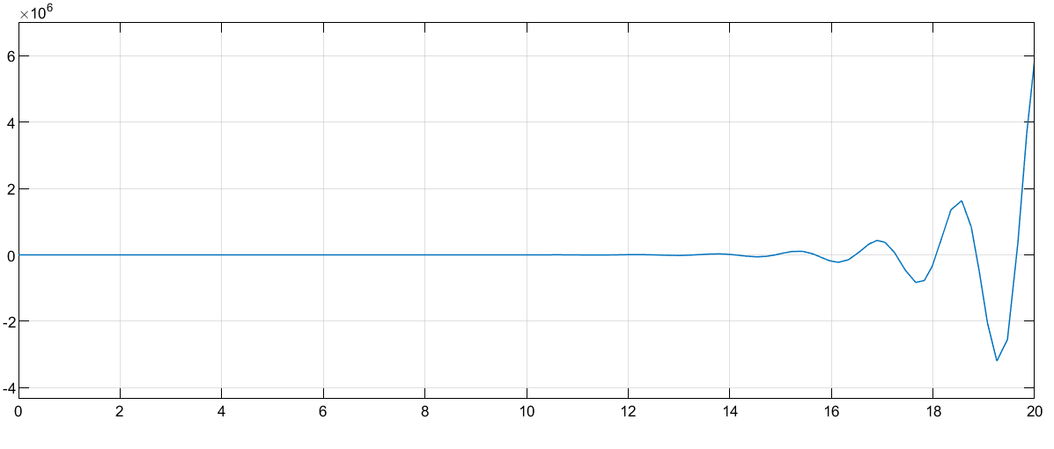

* For K = -100,
  + C = C1 = [0,0,1,0]

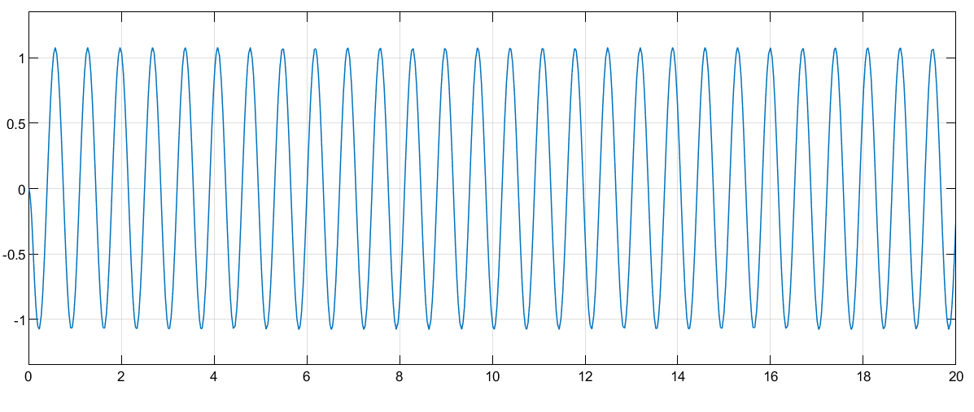

* + C = C2 = [0,0,1,1]

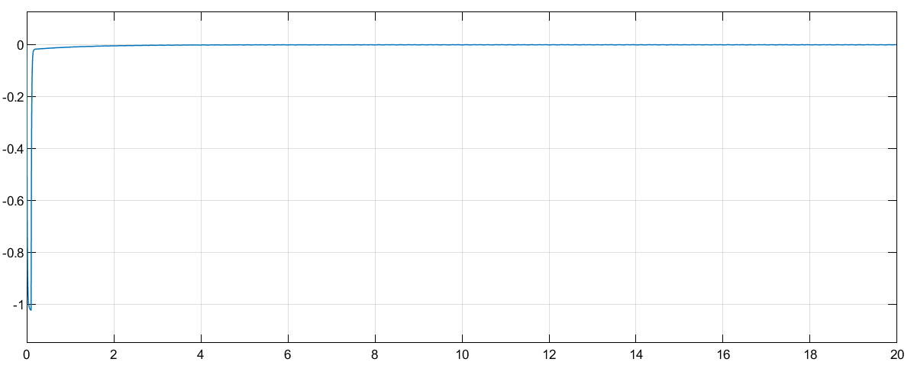

* + C = C3 = [0,1,1,1]

